James’s
--Reviewed Chapter 8 notes
--HW: Finish Chapter 9 and the chapter notes on pg 32 of WB
Working Conditions Anchor Chart pgs 3 & 4 in WB (use quotes on pg 31 in WB to answer the chart)
Category | Ex of Problems | Ex of Fair Working Conditions | Questions to research
Hours | 13 hours/day
Compensation
Health, Safety and Environment | Hard to pull lever (takes strength) and harder to thread shuttle or tie knots  Lyddie had to get her leg cut open and a vaccination poured into the leg (pg 60)  Deafening/extremely  Loud in the weaving room (pg 62-63)  Thick air of dust and lint (pg 63)
Tx of Indv. Workers
Tx of Groups of Workers (Unions) | Forcing them to go to church every Sunday and have the same religion
Child and Forced Labor

--Fair and equitable are being used the same when they are actually not the same thing
--Working conditions: locate examples of working conditions in chapter 8 and figure out where it fits in the chart above (WB pgs 3 & 4)

Chapter 9: pgs 62-73 (novel) and 32-33 (WB)
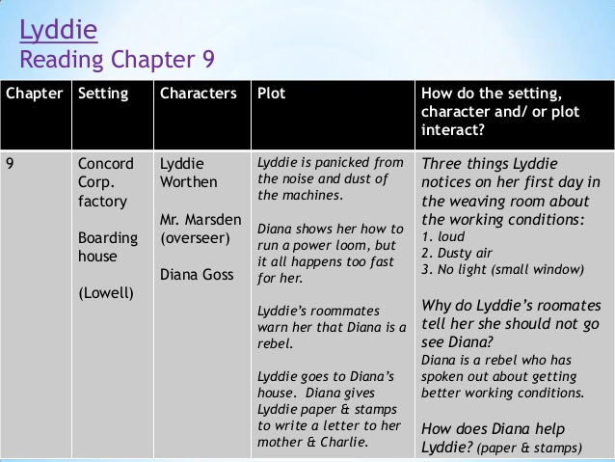
--Lyddie is giving a vivid description of the weaving room and how extremely loud it is inside the room
--dust and air so thick in the room that it reminded her of a very thick soup of dust and lint
--Diana shows and explains what Lyddie has to do at work; the work is very complicated; however, Lyddie masters the job since she is a very hardworking and diligent person
--Dexterity: ability to use one’s hands very well; have fine motor skills
Grant’s Class
Journal #10: Answer the following questions in your journal.
- The stagecoach driver calls Lyddie “a little chip of Vermont granite” (51). Granite is a type of rock? What happened in the chapter to make him say that?
- Lyddie’s roommates call Diana a radical. Diana says that she is infamous. What do these two words mean and why do people use them to refer to Diana?
HW: Read Chapter 11 of “Lyddie.” Complete readers notes questions and vocabulary on WB pg 39.
***Reading Check-in Tomorrow (Thursday, 11/21/19) over chapters 7-11***
--Cloze Read Chapter 10: Oliver pages 74-76
--Chapter 10 of Lyddie Text-Dependent Questions pg 37 & 38

