11/19/19
Jetter’s Class
HW: Finish reading chapter 11 and complete notes on pgs 39-40
Journal #9: Use your novel and reader’s notes from chapters 9 & 10 in order to answer the following four (4) questions:
- What does Prudence mean when she refers to Diana as a “radical” on page 67?
- What does Diana say her “crime” is on page 69?
- In chapter 10, Lyddie completes her first full day in the factory. What is it like for her? Be specific.
- What does Betsy do for Lyddie at the end of chapter?
Mid-unit Assessment on Friday over Chapters 1-13.
DLT/I Can….
- I can use context clues-both in the sentence and on the page—to determine the meanings of unknown words.
- I can analyze how the author’s word choices create vivid descriptions of Lyddie’s living and working conditions.
- I can analyze quotes that show what working conditions in the mill were like and how they affected Lyddie.
Reader’s Dictionary | Chapter 10
Word/Phrase | Page | Definition
Strenuous | 74 | Hard/difficult
Laden | 75 | Heavy/full of
Inferno | 76 | Extreme heat
Commenced | 77 | Start/begin
Ravenous | 78 | Hungry/starving
Fatigue | 78 | Extremely tired

--Reread pgs 74-76….turn to page 37 & 38 in your workbook
--Working conditions Notecard Statements:
a) The air in the factory was humid and dusty
b) The looms were powerful and could injure workers if
they weren’t careful
c) Workers lived and ate in crowded, noisy boardinghouses
Grant’s Class
Journal #9: Create a poem or short story as if you are one of the children working in these conditions in the picture below.
HW: Using pages 62-66 of the novel, add to working conditions anchor chart on workbook pages 3 & 4.
Essential Questions:
- How does setting, characters and plot interact in a text?
- How do they affect the overall meaning of a text?
DLT/I Can:
- I can use context clues—both in the sentence and on the page—to determine the meaning of unknown words.
- I can analyze one section of Lyddie in order to deepen my understanding of the plot, characters and setting.
- I can cite specific textual evidence in order to explain what working conditions were like in the mills and how they affected Lyddie.
--Close Read Chapter 9, pg 62 in novel “The Weaving Room”

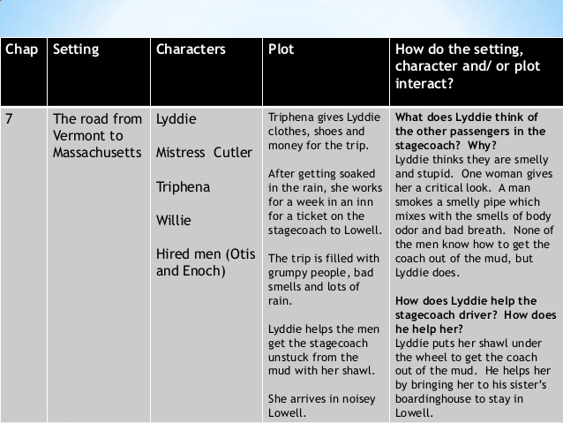

Working Conditions Anchor Chart pgs 3 & 4 in WB (use quotes on pg 31 in WB to answer the chart)
Category | Ex of Problems | Ex of Fair Working Conditions | Questions to research
Hours | 13 hours/day
Compensation
Health, Safety and Environment | Hard to pull lever (takes strength) and harder to thread shuttle or tie knots
Tx of Indv. Workers
Tx of Groups of Workers (Unions)
Child and Forced Labor

