11/22/19 James’s Class
--Read Chapter 12 pgs 86-93
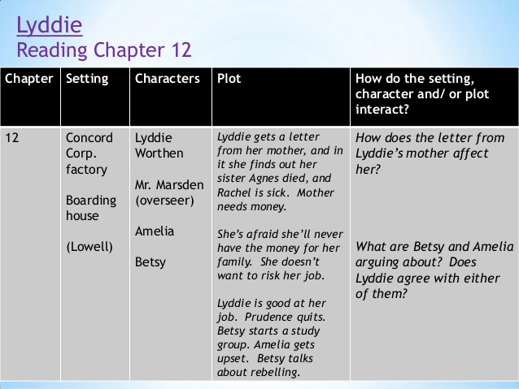
--Lyddie is making more money now than she ever did in Vermont….she is making $2.50/week above her $1.75 board
--Arguments:
a) Betsy: working like slaves and thinks they should sign the petition and move out West
b) Amelia: thinks they should keep their mouths shut because the corporation would blacklist—make it where they can’t get another job them and she feels that it is against the Scriptures—God’s words/Bible—to fight injustices
c) Lyddie: she justs want everyone to be quiet and work because this is the best/most amount of money she’s ever made and that everyone should allow things to be how they are because she needs to pay the family debts off
--Chapter 13, pages 94-105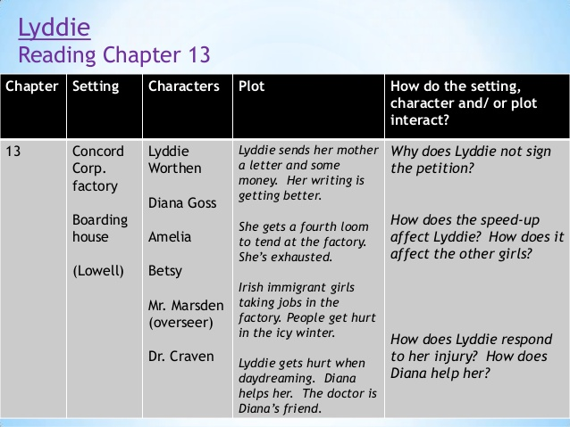
--Lyddie is being affected by the demand of the job
--Lyddie does not sign the petition—the petition is for people to sign that the corporation should give them better working conditions and to allow them to work 10-hour-days—because she wants to keep her job so that she can continue to get paid
--Betsy has decided to sign the petition and go to college in Ohio
--Lyddie has opened a bank account and her money in the account is growing; she wants to send her mother some money but she is also resentful that she has to send her any money
--Lyddie has not seen her mother in two (2) years
--Lyddie is hurt by the shuttle and her head (her right temple) is pouring blood….Diana runs to help her

